Q1 – PROCESSES AND PROCESS STATES
1. Introduction
A process is a program currently under execution. In an online examination server, separate processes may handle student sessions, answer auto-saving and video proctoring.
When 2,000 students log in simultaneously, creating too many processes increases memory usage and context-switching overhead, reducing server performance.
2. Process-State Diagram
A process passes through five main states during execution.

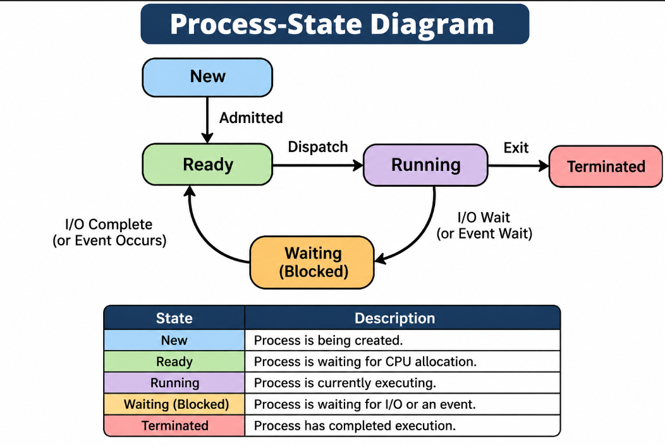

3. Process Control Block (PCB)
A Process Control Block is a data structure maintained by the operating system to store information about each process.
PCB Structure
PCB Component | Description
Process ID | Unique process identification number.
Process State | Current state of the process.
Program Counter | Address of the next instruction.
CPU Registers | Stores current CPU register values.
Scheduling Information | Priority and scheduling details.
Memory Information | Memory allocation details.
I/O Information | Open files and allocated devices.
Accounting Information | CPU time and resource usage.
The operating system uses the PCB during context switching to save and restore process information.
4. C Program Using fork()
The following program creates five child processes using the fork() system call.
#include <stdio.h>
#include <stdlib.h>
#include <unistd.h>
#include <sys/wait.h>
int main()
{
pid_t pid;
int i;
for (i = 0; i < 5; i++)
{
pid = fork();
if (pid < 0)
{
perror("Fork failed");
exit(1);
}
if (pid == 0)
{
printf("Child Process: PID = %d, PPID = %d\n",
getpid(), getppid());
sleep(30);
exit(0);
}
}
printf("Parent Process: PID = %d\n", getpid());
for (i = 0; i < 5; i++)
{
wait(NULL);
}
printf("All child processes completed.\n");
return 0;
}

Compilation
gcc process.c -o process
Execution
./process
The program creates five child processes. Each child displays its process ID and parent process ID.
5. Observing Processes Using ps and /proc
The ps command displays information about running processes.
ps -ef
To display processes belonging to the current terminal:
ps -f
The /proc directory contains information about active processes.
To inspect a process, use:
ls /proc
To view details of a particular process:
cat /proc/<PID>/status
Replace <PID> with the actual process ID.
6. Performance Evaluation with 2,000 Processes
Creating 2,000 separate processes can affect server performance in the following ways:
Factor | Performance Impact
Context Switching | Frequent switching increases CPU overhead.
Memory Usage | Each process requires its own address space and resources.
I/O Waiting | Processes may remain blocked while waiting for disk or network operations.
CPU Utilisation | Excessive process management reduces useful processing time.
Scalability | Managing thousands of independent processes increases system overhead.
Therefore, a separate process for every student may not be an efficient design for a large online examination server.
7. Design Decision
Three possible approaches can be considered.
Design | Advantages | Disadvantages
One Process per Student | Strong isolation and independent execution. | High memory usage and context-switching overhead.
One Thread per Student | Lower memory overhead and faster communication through shared memory. | A failure in the server process can affect all sessions.
Fixed Pool of Worker Processes | Reuses processes and reduces process creation overhead. | Requires task scheduling and session management.

Recommended Design: Fixed Pool of Worker Processes
A fixed pool of worker processes is recommended for the online examination server.
Reasons:
- Reduces the number of active processes.
- Reuses existing worker processes.
- Reduces process creation overhead.
- Provides better isolation than using only threads.
- Improves resource utilisation under heavy workloads.
Student session information can be maintained separately so that worker processes can handle examination requests efficiently.
8. Alternative Concept – One Thread per Student
If each student session uses a thread instead of a separate process, all threads execute within one server process.
Threads share:
- Code section
- Data section
- Heap memory
- Open files
Each thread has its own:
- Stack
- Registers
- Program counter
- Thread ID
Comparison
Factor | Separate Processes | Threads
Memory | Separate address spaces | Shared address space
Context Switching | Generally higher overhead | Generally lower overhead
Communication | Requires IPC | Shared memory
Isolation | Stronger | Weaker
Failure | Usually isolated to one process | A serious process-level failure can affect all threads

A thread typically requires much less memory than a complete process because it shares the process address space.
However, thread stacks and other resources still consume memory.
Complexity Analysis
Let n represent the number of student sessions.

Operation | Time Complexity
Creating n processes | O(n)
Creating n threads | O(n)
Managing n sessions | O(n) for a simple linear management operation
Thread creation and context switching generally have lower overhead than separate processes, although actual performance depends on the operating system and workload.
9. Conclusion
Process management is important for improving online examination server performance. Creating too many processes increases memory usage and context-switching overhead. A fixed pool of worker processes is recommended because it reduces resource consumption while maintaining process isolation and improving scalability.

